## Laravel Multirole Auth

**Step 1:** composer create-project laravel/laravel project-name

**Step 2: Install Breeze**

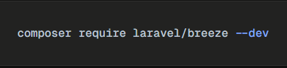

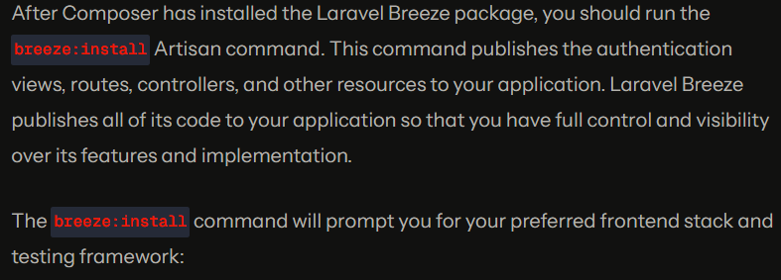



**Step 3: Set up database**

**Step 4:**

php artisan migrate

npm install

npm run dev

**Step 5: Create user based on roles**

**Step 6: Create a controller**



**Step 7: Write the index() function**

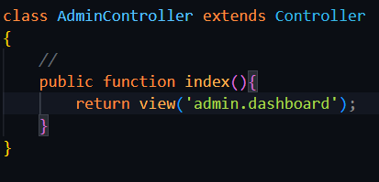

**returns the desired view**

**Step 8: Create middleware so that no other roles can access this route**



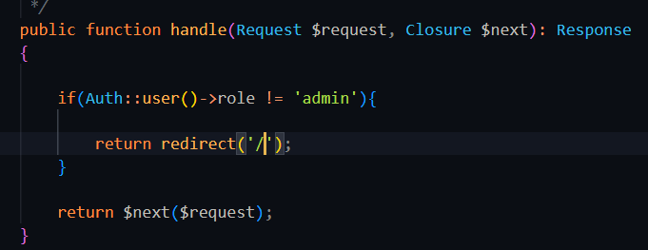

**Step 9: Register the middleware inside bootstrap/app.php**

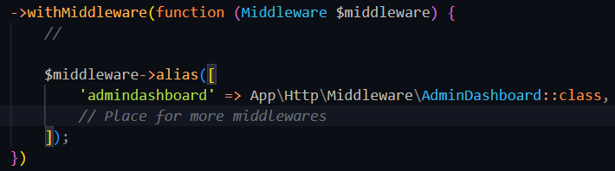

**Step 10: Update Route with Controller and Middleware Alias**



**Step 11: Routing after authentication:**

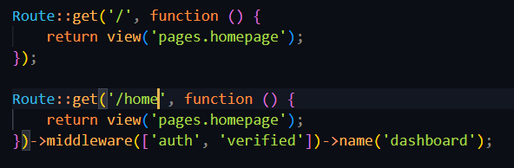

**Inside AuthenticatedSessionController:**

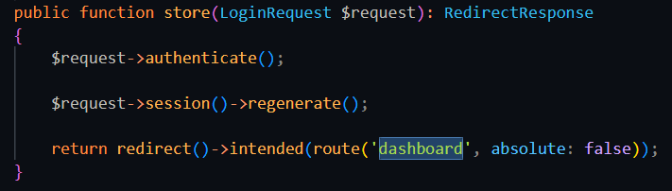

**Inside RegisteredUserController:**

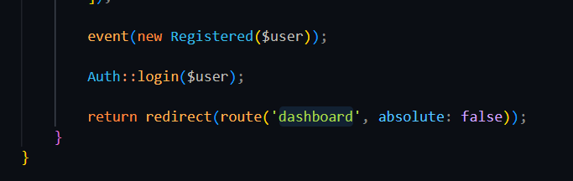

**Other Concepts:**

